CREATE DATABASE

The CREATE DATABASE statement is used to create a new SQL database. The schema you create is, in fact, a database(MSSQL_Workbench).

Syntax: CREATE schema databasename;

Eg : CREATE schema mssqlpractise;
-----------------------------
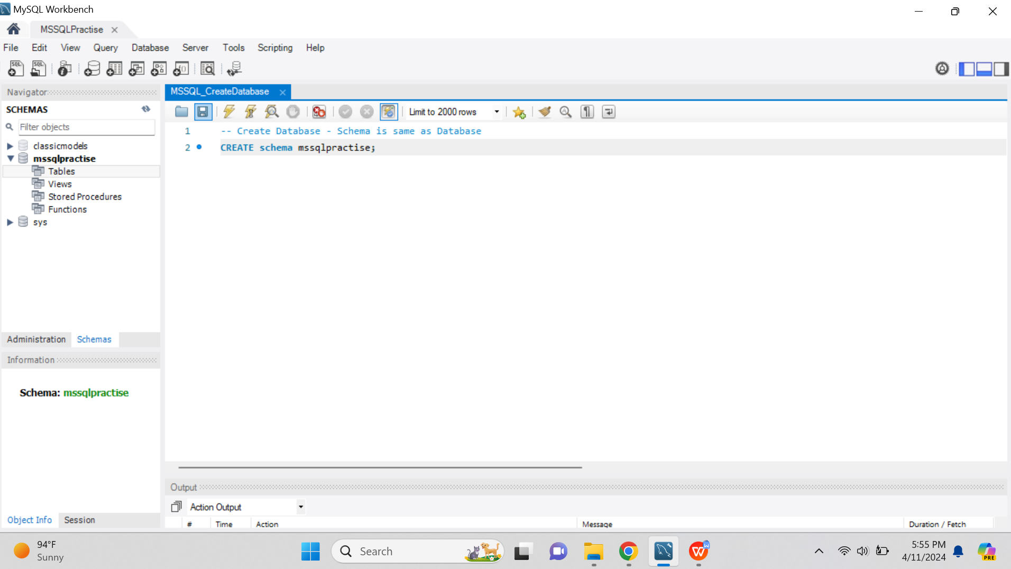

Make sure you have admin privilege before creating any database.
Once a database is created, you can check it in the list of databases with the following SQL command:
-----------------------------
SHOW DATABASES;
-----------------------------

